GRADE 7 ACCELERATED · UNIT 1 · LESSON 2  Repeating Decimals to Fractions  Additional Practice 7A.01.02 | Name_________________________  Date__________________________  Period________________________

Use the repeating decimal 0.5888… for questions 1 through 4.
1. Let x = 0.5888… Complete each equation.
 | 10x | = ____________________

 | 100x | = ____________________

2. Which two values, when subtracted, leave a whole number? Fill in one bubble.
○ 10x and x
○ 100x and x
○ 100x and 10x

3. Use two of the equations from question 1 to find the fraction equivalent of 0.5888… Show the subtraction step.

4. Write 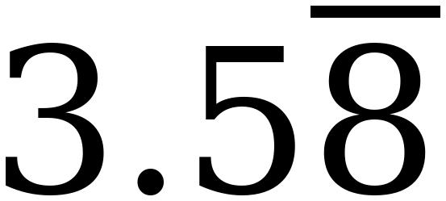 as a fraction and as a mixed number.

A trail mix recipe uses these amounts: raisins 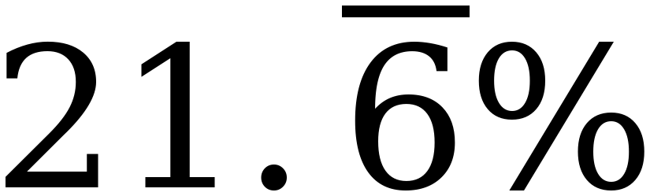, peanuts 5/9, chocolate chips 0.14, and the rest is chex mix.
The bar means the 6 repeats forever.

5. What fraction of the recipe is chocolate chips?

6. What fraction of the recipe is raisins?

7. What is the decimal equivalent of the peanuts?

8. About what percent of the recipe is chex mix? Round to the nearest whole percent.

For questions 9 and 10, complete the table.
 | Decimal | Percent | Fraction or Mixed Number
9. | 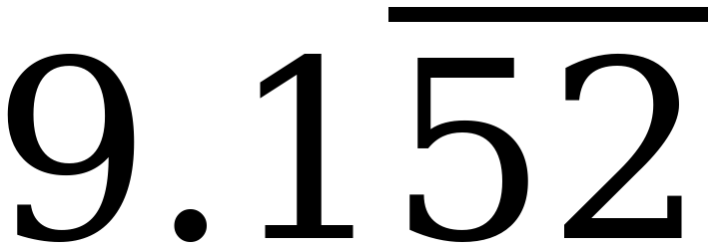
10. |  | 

